- Tool for Commanders to provide an immediate positive impact on Soldiers.

- Authorizes the immediate Commander (Company Commander or 1SG) limited authority to provide AER assistance.

- Soldier is provided with an additional option other than payday lenders.

- Commanders and 1SGs are still required to operate within existing guidelines and
procedures IAW AR 930-4.

- Soldiers can request up to $2,000.00 in assistance by submitting AER Form to their immediate Commander/1SG 101 (checking Quick Assist Program in box 16, page 3). Application includes AER Form 57 Budget Sheet to assist with evaluating ability to repay debt in a 12-15 month period.

- Commander/1SG must be satisfied that the Soldier’s request is reasonable, justifiable, and needed.

- If approved, Commander/1SG will complete items 21-24e on AER Form 101 Soldier ten calls the AER Office for an appointment, at 255-2341.

- Commander/1SG is the approving authority – not the AER Officer.

- Some conditions apply:
  - Previous existing loan, under the Quick Assist Program, must be repaid before additional assistance in this category is authorized.
  - There will be no more than two (2) Quick Assists per year.
  - Requested amount and current balance of any existing loan cannot exceed $3,000.00.
  - Repayment must be by allotment.
  - Active duty, RA Soldiers only. Reserve component (NG/AR) Soldiers do not qualify (may apply through routine assistance request).
  - Repayment must be 60 days prior to ETS, typically repaying over a 12 month period (repayment may be delayed up to 3 months from date of assistance or extended to 15 months to avoid hardship ).
  - Soldier cannot be on the AER restricted list.
  - Soldier cannot have current or pending bankruptcy (Utilize AER Form 101 Routine Request, for this situation).
  - Assistance under this category will always be as a loan, no grants are authorized. Emergency Travel is the only exception, provided as a half loan/half grant.
  - AER Officer will confirm eligibility for assistance under this category prior to issuing a check. If Soldier does not meet eligibility for assistance under the Quick Assist Program, Soldier may apply utilizing AER Form 101 Routine Request procedure.
  - AER Officer will inform the Commander or 1SG of final disposition.
- Responsibility of AER under this program is to educate and monitor.

- Commanders/1SGs who do not desire to approve assistance under the Quick Assist Program may still recommend approval using the same form, however in addition to completing Section 21-24e the Routine assist block is marked in Section 16 instead of the QAP box.

Authorized Categories of Assistance
- Food
- Fuel for POV*
- Rent or past due mortgage (primary residence only)
- Utilities
- Emergency leave transportation, lodging and food
- POV repairs *
- POV loan payment *
- POV insurance *
- Purchase or repair of stove, refrigerator, washer, or dryer (primary residence only)
- Purchase or repair of HVAC (primary residence only)
- Purchase of essential/economical furniture (set up of initial household or loss due to natural disaster only)
- Necessary medical /hospital expenses not covered by insurance except those noted below.
- Dependent funeral expenses
- Above categories of assistance when pay is delayed or stolen (no-pay due or non-receipt of advance travel for PCS moves)
- Above assistance due to fire or other natural disaster.

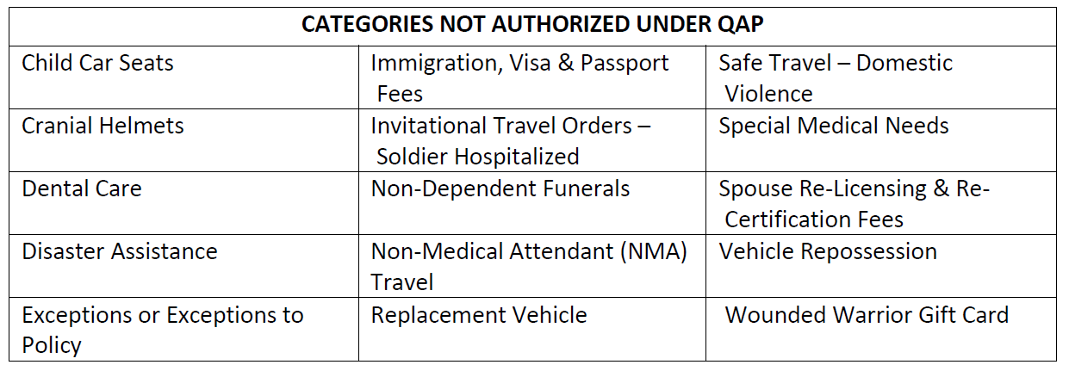

- Point of contact for Fort Rucker AER is Beth Gunter, 255-2341, mary.b.gunter.civ@mail.mil. Additional information on Army Emergency Relief may be found at https://www.aerhq.org/.

*Please verify current driver’s license, POV registration, and insurance (must be in Soldier’s and/or spouse’s name).

