Getting through the Gate:
If you do not have a DoD issued ID, you may acquire a visitor’s pass for gate access online between 5 and 30 days prior to the event. Visit https://pass.aie.army.mil to obtain a visitor’s pass.
When you arrive:
Event participant parking is located behind the Family Life Center (bldg. 8939) and the Main Post Chapel (bldg. 8940) on Red Cloud Road.
You may coordinate with friends to carpool to start point. Carpool parking/drop off is located at the Soldier Service center, Building 5700 parking lot.
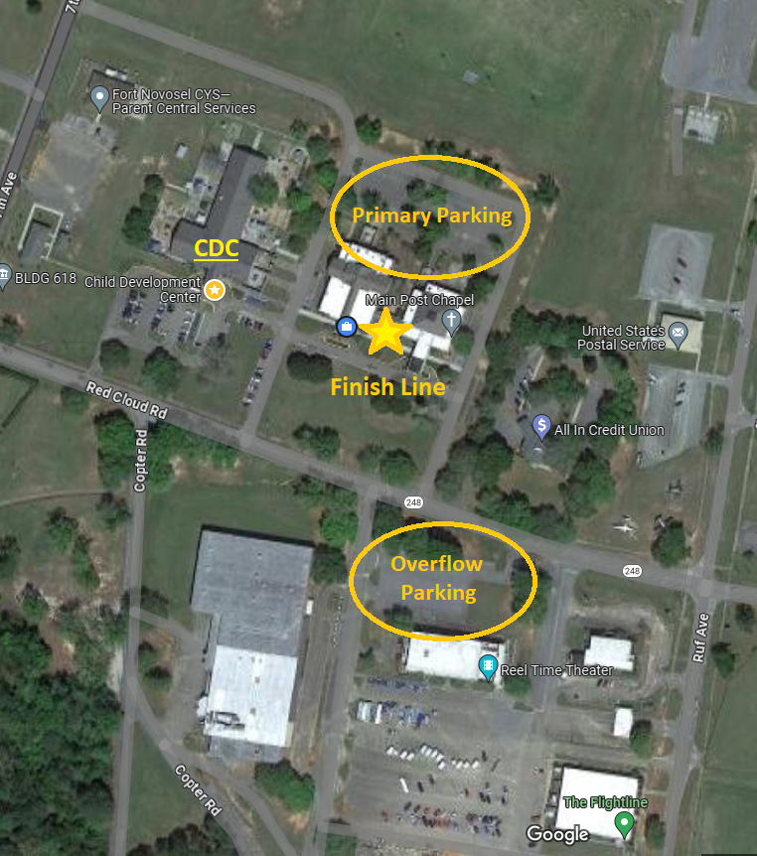
If unable to carpool, a shuttle will be provided to transport participants to the start point.
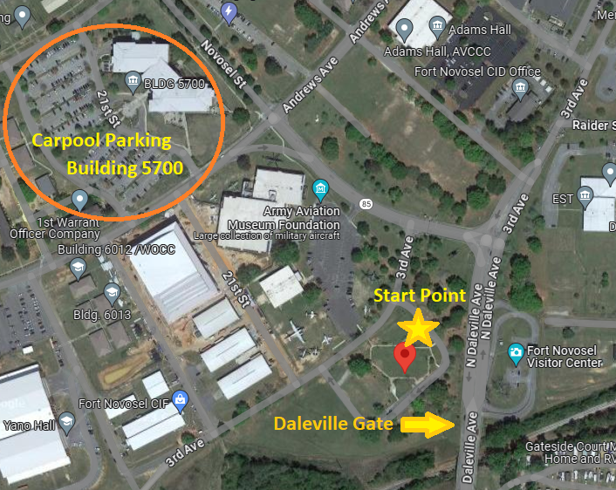

Packing list
- Hydration device
- Reflective gear
- Rucksack or backpack
- Cold weather gear (if necessary)
- Wet Weather gear (if necessary)
- Consider bringing some lightweight material to fill the bottom of your bag and allow most of the weight to rest as high as possible within your ruck. (i.e. towels, blankets, pillow)

