Ask about our Hotel Voucher Programs  Military Hotel Voucher  Comfort Inn & Suites Universal  Standard $79.00 - $133.00 Suite $90.00 - $144.00  Holiday Inn Express & Suites  Standard $80.00 Suite $94.00  Holiday Inn Orlando SW – Celebration  Standard $76.00  Lake Buena Vista Resort Village & Spa  2 – 3 Bedroom Condos  $136.00 - $175.00  Magic Village Views/Yards  3- & 4-Bedroom Villa  $182.00 - $406.00  Rosen Inn at Pointe Orlando  Standard $64.00 - $88.00  ALL SALES ARE FINAL NO REFUNDS OR EXCHANGES  *PRICES SUBJECT TO CHANGE*  Tennessee Gatlinburg/Pigeon Forge  Alcatraz Adult $20.00/Child $16.00/Senior (61+) $20.00  Wonder Works All Access Ad (13+) $25.00 Ch (3-11) $20.00  Titanic Ad (12+) $29.00 Ch (3-11) $13.00  Family (2 adults up to 4 children ages 18 an under) – $103.00  Graceland Experience – Memphis  Adult (12+) $69.00/Child (3-11) $40.00 VIP (5+) $116.00  Dollywood –  1 Day Adult $ 1 Day Child (4-9)/SR (61+) $  2 Day Adult $ 2-day Child (4-9)/SR (61+) $  Madame Tussauds Nashville  Amber Falls Wine Tasting $23.00  All Access Ad $18.00 Ch $14.00  The Adventure Park at Nashville & Playground  Adult $42.00 Youth (7-13) $37.00 Playground Child (3-6) $18.00 |  |  | MWR Leisure Travel  Fort Novosel  BLDG 212 Ruff Ave  Monday – Friday  10am – 5pm  Saturday  10am – 2pm  Office (334)255-2997/9517  usarmy.novosel.id-training.mbx.dfmwr-leisure-travel-services@army.mil  2024 Disney World & DisneyLand Tickets  Are on Sale!!  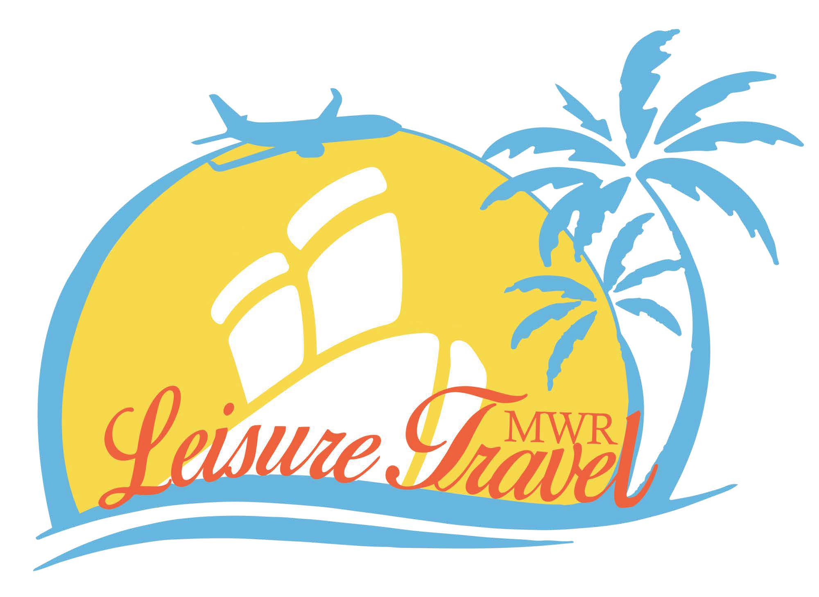  2024 Universal Studios Freedom Passes  On sale!!  anges  *Prices Subject to Change*
MILITARY SPECIAL 2024  1 Day Ticket  Base Adult $120.00 Park to Park Adult $169.00 Base Child $115.00 Park to Park Child $165.00  2 Parks  2 Day Base Adult $223.00 Park to Park Adult $283.00  2 Day Base Child $213.00 Park to Park Child$273.00  3 Day Base Adult $244.00 Part to Park Adult $304.00  3 Day Base Child $234.00 Park to Park Child$294.00  4 Day Base Adult $258.00 Park to Park Adult $323.00  4 Day Base Child $248.00 Park to Park Child $313.00  5 Day Base Adult $271.00 Park to Park Adult $341.00  5 Day Base Child $261.00 Park to Park Child $331.00  Universal Studios, Island of Adventure & Volcano Bay  3 PARKS  3 Day Base Adult $284.00 Park to Park Adult $344.00  3 Day Base Child $274.00 Park to Park Child $334.00  4 Day Base Adult $308.00 Park to Park Adult $373.00  4 Day Base Child $298.00 Park to Park Child $363.00  5 Day Base Adult $331.00 Park to Park Adult $401.00  5 Day Base Child $321.00 Park to Park Child $391.00  Six (6) tickets per for card holder may purchase by Active duty, Retired, National Guard, Reservist, U.S. Coast Guard, or their spouse with a valid U.S. Military ID. DOD Civilian’s may purchase tickets with a valid U.S Military CAC Card with approved ID. We will be checking IDs to ensure you have the correct ID to purchase the tickets. You need to purchase all 6 tickets at one time. Once you have activated a ticket in your name, you will not be able to purchase any more under your name. The Freedom Pass does not include parking or other special perks. Once Universal has issued your tickets, please take photo of the back of your ticket!  Tickets Valid from 16 Nov 23 – 20 Dec 24  Universal Studios, Islands of Adventure Freedom Pass  2-Park Freedom Adult (10+) $210.00/Child (3-9) $205.00  Universal Studios, Islands of Adventure & Volcano Bay Freedom Pass  3 Park Freedom Adult (10+) $245.00/Child (3-9) $240.00  Blackout Dates- 25 Dec 2023 – 2 Jan 2024 & 25-31 March 2024  Tickets expire 20 December 2024  Universal Hollywood  1 Day Gen. Admission $112.00 |  |  | CENTRAL FLORIDA  GATORLAND ORLANDO - Military Free  Adult (14+) …$27.00/Child (3-13) …$20.00  Gatorland Zip Line (includes admission) $55.00  LEGOLAND – Winter Haven – 1 Day 2nd Day Free (2+) $76.00  1 Day 2nd D Waterpark Free (2+) $93.00  1 Day 2nd D Peppa Pig (2+) $97.002 Day Legoland, Waterpark & Peppa Pig (2+) $114.00  Valid for 2 days at LEGOLAND Florida, Same ticket must be used for both days, 2nd day must be used within 14 days of first visit or before expiration, or whichever comes first.  Fun Spot of Florida, Orlando  1 day park pass (3+) $47.00 Fun Spot FL MIL 1 DAY $24.00  Kennedy Space Center Adult (12+) $58.00/Child (3-11) $51.00  Kennedy Atlantis Annual Pass Ad $123.00 Ch $99.00  Kennedy Chat Astro Ad $47.00 Ch $33.00  Medieval Times – Kissimmee Adult (12+) …$53.00/Child (3-11) …$36.00  Sleuth’s mystery dinner show Adult (12+) …$48.00/Child (3-11) …$27.00  ICON Orlando Adult (10+) … $16.00/Child (3-9) …$13.00  Wonder Works Orlando all Access Open Daily: 9am – 12am  Adult $25.00 Child (4-12)/Senior $20.00  All Wonder Works Exhibits, The 4D XD Motion Theater, The Glow-In-The-Dark Ropes Course*, (1) Game of Laser Tag. *Ropes Course Requires: Closed toe shoes & onsite signed waiver.  Wonder Works Orlando Outta Control Magic Comedy Dinner Show  Adult $28.00/Child (4-12) $20.00  This dinner show is interactive, entertaining, and hilariously funny and includes UNLIMITED cheese/pepperoni pizza, salad, dessert, soft drinks, beer & wine. Reservations required.  Sea Life @ Orlando Adult $24.00/Child (3-12) $20.00  Crayola Experience General Admission $27.00  Andretti Indoor Karting & Games  Andretti +More Adult $49.00 Child $41.00  Andretti Race/Game Adult $27.00 Child $20.00  Andretti 1 Race Adult $21.00 Child $13.00  Boggy Creek Airboats Rides  Boggy Creek 30 Min. Adult $28.00 Child $24.00  Boggy Creek 1 Hour Adult $45.00 Child $41.00  Boggy Creek 30 Min Ultimate Tour Adult $46.00 Child $36.00  Boggy Creek 1 Hour Ultimate Tour Adult $63.00 Child $52.00  Ultimate includes meal & mining.
CENTRAL FLORIDA |  |  | 5

Panama City Beach/Destin  Wonder Works Panama City  Adult $25.00/Child (5-12)/Senior (60+) $20.00  Tampa  FLORIDA AQUARIUM- TAMPA, FLORIDA  One day pass adult (12+) $30.00 (60+) $27.00 Child (3-11) $26.00  CITY PASS TAMPA Adult (10+) $125.00 Child (3-9) $112.00  Present your tickets on a mobile device (or print them) for entry to the included attractions: Busch Gardens® Tampa, The Florida Aquarium, Zoo Tampa at Lowry Park, Clearwater Marine Aquarium, Museum of Science & Industry (MOSI) OR The Tropic Boat Tours. CityPASS® mobile tickets are valid for 9 days, beginning with the first day of use.  Sea World/Busch Gardens/Discovery Cove/Aquatic/Adventure Island  Discovery Cove – Day Resort Package  Package Includes: Self-parking, dolphin swim lesson, food and beverages (includes a light continental breakfast and lunch), use of snorkel equipment, wet suits, towels, lockers, 1 pass to SeaWorld Orlando and Aquatic valid 14 consecutive days before or after the visit date to Discovery Cove. Tickets are non-transferable. Ask us how to take advantage of this package!  Dolphin Swim Ad/Ch (3+) $258.00 Non-Swim Ad/Ch (3+) $178.00  Discovery Cove Ultimate Package - Ultimate Packages include self-parking, food and beverages including a light continental breakfast and freshly prepared lunch, use of snorkel equipment, wet suits, towels and lockers and a pass to SeaWorld Orlando, Busch Gardens Tampa and Aquatic Orlando valid for fourteen (14) consecutive days before or after the visit date to Discovery Cove (non-transferable). Package includes roundtrip transportation to Busch Gardens Tampa on the Busch Gardens Shuttle Express. * Discovery Cove ULTIMATE Dolphin SWIM Package is available to anyone six (6) years of age or older, includes a required prep-class and dolphin swim session  Ultimate Dolphin Swim Ad/Ch (3+) $285.00 non-swim $205.00  Aquatic – 1 Day Military $50.00  1 Day Military w/all day dine $73.00  1 Day $66.00 1 Day with all day dinning $96.00  Busch Gardens 1 Day $101.00 0r 1 Day with all day dine $133.00  Adventure Island – 1 Day $50.00 Adventure FNCD $88.00  Sea World 1 Day Admission  Military 1 Day (3+) $68.00 Military All Day Dine 1 Day (3+) $93.00 |  |  | Georgia  Wild Adventures  1 Day Gen. Ad. 2 Day Gen. Ad.  Georgia Aquarium Gen. Ad.  Atlanta Zoo Ad (13+) $27.00 Ch (3-12) $22.00  Fun Spot America of Atlanta  Fun Spot 1 Day $30.00 Fun Spot Military 1 Day $24.00  Medieval Times near Atlanta Ad (13+)$50.00 Ch(3-12)$35.00  Six Flags Over Georgia - Gen Admission $  White Water – Gen. Admission $  Lego Discovery Center Georgia Adult/Child (3+) $21.00  Atlanta City Pass Adult (13+) $89.00 /Child (3-12) $69.00  Georgia Aquarium, World of Coca-Cola, Zoo Atlanta, Fernbank Museum of Natural History, Chick-fil-A College Football Hall of Fame, National Center for Civil and Human Rights. CityPASS® tickets are valid for 9 days, beginning with the first day of use. Plus, your choice of admission to 2 of the following attractions: Fernbank Museum of Natural History or Chick-fil-A College Football Hall of Fame or National Center for Civil and Human Rights  South Carolina  Medieval Times Ad $58.00 Ch $39.00  Riverbanks Zoo & Garden  1 Day admission + parking Ad $22.00  1 Day admission Ch $19.00  Legends In Concerts – Ask about the Concert Schedule  Bronze Ad $35.00 Ch $14.00  Silver Ad $40.00 Ch $15.00  Gold Ad $44.00 CH $17.00  Pennsylvania  Hershey Park 1 Day Hershey Regular - $55.00  Legoland Discovery Cent. Ad $20.00 Ch $20.00  New Jersey  Nickelodeon Universe – 1 day 3+ $51.00  Dreamwork Water Park – 1 day 3+ $62.00  Louisiana  New Orleans National World War II Museum  NTL WW2 BYND Bound $40.00  NTL WW2 Camps Pass $30.00
Disney World Military Salute Tickets 2024  4 Day Park Hopper $365.00 4 Day Park Hopper PL $395.00  5 Day Park Hopper $385.00 5 Day Park Hopper PL $415.00  6 Day Park Hopper $400.00 6 Day Park Hopper PL $435.00  PL – Water Park and Sports  Valid 1 January 2024 – 20 December 2024  Black Out Dates Military Salute 2024  23 March 2024 through 7 April 2024  24 November 2024 through 30 November 2024  Tickets will Expire on 20 December 2024  Disney World After Hours  Ask for Ticket Details  We are now selling Disney After Hours Special Tickets for Epcot, Magic Kingdom, and Hollywood Studios.  Ticket is valid only for admission to the Disney After Hours event at Epcot, Magic Kingdom, and Hollywood Studios during the following times on the date specified for that Ticket: 7:00 pm to 1:00 am (with the event running three hours, from 10:00 pm to 1:00 am)  Note: Disney After Hours at Disney's Epcot, Magic Kingdom and Hollywood Studios is a special event that requires a separate admission charge.  Official check-in for the event will take place at the Main Entrance to the Disney's Epcot beginning at 7:00 pm  Please note that the number of Tickets available is limited. Events may sell out. In addition, all Tickets are non-refundable, non-transferrable and are only valid for admission during the special event date and hours.  Please note that not all attractions, entertainment and experiences at Disney's Epcot, Magic Kingdom and Hollywood Studios are available during the events. The events schedule and available attractions, entertainment and experiences during the events are subject to change without notice. Parking is not included.  Disneyland, California Military Salute 2024  3 Day Park Hopper $269.00 3 Day Park Hopper w/Genie $359.00  4 Day Park Hopper $315.00 4 Day Park Hopper w/Genie $435.00  Valid January 2, 2024 - December 13, 2024  WALT DISNEY WORLD |  |  | 1 Day – Any Park 1 Day Park Hopper  Adult (10+) … $179.00 Adult (10+) … $261.00  Child (3-9) …. $174.00 Child (3-9) … $256.00  2 Day – Any Park 2 Day Park Hopper  Adult (10+) … $265.00 Adult (10+) … $347.00  Child (3-9) … $256.00 Child (3-9) … $337.00  3 Day – Any Park 3 Day Park Hopper  Adult (10+) … $ 355.00 Adult (10+) … $429.00  Child (3-9) … $341.00 Child (3-9) … $416.00  4 Day - Any Park 4 Day Park Hopper  Adult (10+) … $455.00 Adult (10+) … $540.00  Child (3-9) … $434.00 Child (3-9) … $522.00  5 Day – Any Park 5 Day Park Hopper  Adult (10+) … $502.00 Adult (10+) … $587.00  Child (3-9) … $ 484.00 Child (3-9) … $ 568.00  6 Day Any Park 6 Day Park Hopper  Adult (10+) $522.00 Adult (10+) $607.00  Child (3-9) $503.00 Child (3-9) $587.00  7 Day Any Park 7 Day Park Hopper  Adult (10+) $529.00 Adult (10+) $614.00  Child (3-9) $510.00 Child (3-9) $594.00  8 Day Any Park 8 Day Park Hopper  Adult (10+) $561.00 Adult (10+) $646.00  Child (3 -9) $556.00 Child (3-9) $624.00  9 Day Any Park 9 Day Park Hopper  Adult (10+) $578.00 Adult (10+) $663.00  Child (3-9) $556.00 Child (3-9) $641.00  10 Day Any Park 10 Day Park Hopper  Adult (10+) $594.00 Adult (10+) $679.00  Child (3-9) $572.00 Child (3-9) $657.00  Please create your account with MyDisneyExperience.com, as Disney requires Park Reservations. Please remember that these tickets will expire 14 days after 1st day park entrance.  Disney Water Park & Seasonal Tickets  1 Day Water Park Adult (10+) $76.00 - Child (3-9) $69.00  No Blackout dates, some activities/events may be separately priced.  1 Day Magic Your Way Seasonal Base Ticket – Blackout dates apply.  Adult (10+) $141.00  Child (3-9) $136.00  1 Day Magic Your Way Seasonal Park Hopper – Blackout dates apply.  Adult (10+) $217.00  Child (3-9) $212.00  Blackout Date  16 Dec 2023 – 31 Dec 2023  14 Dec 2024 – 31 Dec 2024  13 Dec 2025 – 31 Dec 2025 | 1

